**LAPORAN FINAL PROJECT ALGORITMA PEMROGRAMAN**



**Disusun oleh :**

**‘KADANG KODING TEAM’**

1. **Nama Anggota Beserta Tugasnya Masing-masing**
2. Luky Mulana (1810631170200)

* >> Membuat kerangka program
* >> Membuat flowchart program.

1. Rona Febriana (1810631170246)

* >> Mengisi database program
* >> Mengatur tampilan program.

1. **Deskripsi Fasilitas Aplikasi**

Program yang kami buat bernama Inventori Gudang. Dimana program ini berfungsi untuk menyimpan, menginput, dan melihat stok sebuah barang. Bisa berupa makanan, alat tulis, dan seragam.

Sederhananya program yang kami buat seperti gudang barang-barang. Ketika kita mencoba input data atau menginput sebuah barang, maka dengan otomatis barang akan tersimpan di gudang tersebut.

Semoga dengan dibuatnya program ini bisa memudahkan manusia untuk mengelola dan memonitoring barang-barang digudang penyimpanan.

1. **Source Code Project**

Berikut ini adalah source code program yang kami buat :

#include<iostream>

#include<iomanip>

#include <ostream>

#include<windows.h>

#include<conio.h>

#include <fstream>

#include <stdlib.h>

#include <dos.h>

using namespace std;

void header(), makanan(), alat_tulis(), seragam(), loading(), login(), menu(), daftar(), verifikasi();

string userbaru;

string passbaru;

main()

{

loading();

system("cls");

login();

system("cls");

}

void menu()

{

int pilih;

header();

cout << "--------------------"<< endl;

cout << "| [1]. Makanan |" << endl;

cout << "--------------------" << endl;

cout << "| [2]. Alat Tulis |" << endl;

cout << "--------------------" << endl;

cout << "| [3]. Seragam |" << endl;

cout << "--------------------" << endl;

cout << "| [4]. Keluar |" << endl;

cout << "--------------------" << endl<<endl;

pilih2 :

cout << ">> Masukan Pilihan Anda : ";

cin >> pilih;

switch(pilih)

{

case 1: makanan(); break;

case 2: alat_tulis(); break;

case 3: seragam(); break;

case 4: exit(EXIT_FAILURE); break;

default :

cout << "Pilihan Anda Tidak Tersedia\n" << endl;

goto pilih2;

}

}

void header()

{

cout << "======================***=====================" << endl;

cout << ">> Aplikasi Inventori Gudang 'Kadang Koding'<<" << endl;

cout << "======================***=====================" << endl<<endl;

}

void makanan()

{

int pilih;

awal_makanan :

system("cls");

header();

cout << "===========***===========" << endl;

cout << ">> Penyimpanan Makanan <<" << endl;

cout << "===========***===========" << endl<<endl<<endl;

cout << "---------------------" << endl;

cout << "++ 1. Input Barang ++" << endl;

cout << "---------------------" << endl;

cout << "++ 2. Cek Stok ++" << endl;

cout << "---------------------" << endl;

cout << "++ 3. Kembali ++" << endl;

cout << "---------------------" << endl<<endl;

pilih1 :

cout << ">> Masukan Pilihan Anda : ";

cin >> pilih;

if (pilih == 1)

{

int a;

struct data{

int jumlah;

string nama;

string satuan;

} barang[20];

simpan :

cout << "\n>> Masukan Jumlah Barang Yang Ingin di Input >> : ";

cin >> a;

cout<<endl;

for (int i=1; i<=a; i++)

{

cout << ">> - - - - - - - - - - - - - - - - - - - - - " << endl;

cout << ">> Data Barang ke - " << i << endl;

cout << "> Nama Barang : ";

cin >> barang[i].nama;

cout << "- - - - - - - - - - - - - - - - - - - - - " << endl;

cout << "> Jumlah Barang : ";

cin >> barang[i].jumlah;

cout << "- - - - - - - - - - - - - - - - - - - - - " << endl;

cout << "> Satuan Barang (Buah/Kg/Bungkus/...) : ";

cin >> barang[i].satuan;

cout << "------------------------------------------" << endl;

//simpan

ofstream simpan_barang;

simpan_barang.open("db_barang.txt", ios :: app);

for (int i=1; i<=a; i++)

{

simpan_barang << barang[i].nama << "\t";

simpan_barang << "\t" << barang[i].jumlah << "\t";

simpan_barang << "\t" << barang[i].satuan << endl;

simpan_barang.close();

}

}

cout << "\n Data Sukses Disimpan " << endl;

cout << "\n No";

cout << "\t Nama Barang";

cout << "\t Jumlah Barang";

cout << "\t Satuan" << endl;

for (int i=1; i<=a; i++)

{

cout << " " << i;

cout << "\t " << barang[i].nama;

cout << "\t\t " << barang[i].jumlah;

cout << "\t\t " << barang[i].satuan << endl;

}

kembali1 :

char yn;

cout << "\n>> Apakah Anda ingin input data lagi? (Y/N) : ";

cin >> yn;

if (yn == 'Y' || yn == 'y')

{

goto simpan;

}

else if (yn == 'N' || yn == 'n')

{

goto awal_makanan;

}

else

{

cout << ">> Masukan huruf Y atau N !!!" << endl;

goto kembali1;

}

}

else if (pilih == 2)

{

string baca;

string baris;

ifstream data;

data.open ("db_barang.txt"); // membuka file dataku.txt

while(!data.eof()) //membaca data secara keseluruhan

{

getline(data, baris);

baca += baris+"\n";

}

data.close();

system("cls");

header();

cout << "\nNama Barang";

cout << "\tJumlah Barang";

cout << "\tSatuan" << endl;

cout << baca; // menampilkan data ke layar

char yn;

kembali2:

cout << "\n>> Apakah Anda kembali? (Y/N) : ";

cin >> yn;

if (yn == 'Y' || yn == 'y')

{

goto awal_makanan;

}

else if (yn == 'N' || yn == 'n')

{

exit(EXIT_FAILURE);

}

else

{

cout << ">> Masukan huruf Y atau N !!!" << endl;

goto kembali2;

}

getch();

}

else if (pilih == 3)

{

system("cls");

menu();

}

else

{

cout << "Pilihan Anda Tidak Tersedia \n" << endl;

goto pilih1;

}

}

void alat_tulis()

{

int pilih;

awal_alat :

system("cls");

header();

cout << "=============***============" << endl;

cout << ">> Penyimpanan Alat Tulis <<" << endl;

cout << "=============***============" << endl<<endl<<endl;

cout << "---------------------" << endl;

cout << "++ 1. Input Barang ++" << endl;

cout << "---------------------" << endl;

cout << "++ 2. Cek Stok ++" << endl;

cout << "---------------------" << endl;

cout << "++ 3. Kembali ++" << endl;

cout << "---------------------" << endl<<endl;

pilih3 :

cout << ">> Masukan Pilihan Anda : ";

cin >> pilih;

if (pilih == 1)

{

int a;

struct data{

int jumlah;

string nama;

} alat[20];

simpan_alat_tulis :

cout << "\n>> Masukan Jumlah Barang Yang Ingin di Input : ";

cin >> a;

cout<<endl;

for (int i=1; i<=a; i++)

{

cout << ">> - - - - - - - - -" << endl;

cout << ">> Data Barang ke - " << i << endl;

cout << "> Nama Barang : ";

cin >> alat[i].nama;

cout << "- - - - - - - - -" << endl;

cout << "> Jumlah Barang : ";

cin >> alat[i].jumlah;

cout << "- - - - - - - - -" << endl;

//simpan

ofstream simpan_alat;

simpan_alat.open("db_alat_tulis.txt", ios :: app);

for (int i=1; i<=a; i++)

{

simpan_alat << alat[i].nama << "\t";

simpan_alat << alat[i].jumlah << endl;

simpan_alat.close();

}

}

cout << "\nData Sukses Disimpan " << endl;

cout << "\nNo";

cout << "\tNama";

cout << "\tJumlah Barang" << endl;

for (int i=1; i<=a; i++)

{

cout << i;

cout << "\t" << alat[i].nama;

cout << "\t" << alat[i].jumlah << endl;

}

kembali :

char yn;

cout << "\n >> Apakah Anda ingin input data lagi? (Y/N) : ";

cin >> yn;

if (yn == 'Y' || yn == 'y')

{

goto simpan_alat_tulis;

}

else if (yn == 'N' || yn == 'n')

{

goto awal_alat;

}

else

{

cout << ">> Masukan huruf Y atau N !!!" << endl;

goto kembali;

}

}

else if (pilih == 2)

{

string baca;

string baris;

ifstream data;

data.open ("db_alat_tulis.txt"); // membuka file dataku.txt

while(!data.eof()) //membaca data secara keseluruhan

{

getline(data, baris);

baca += baris+"\n";

}

data.close();

system("cls");

header();

cout << baca; // menampilkan data ke layar

char yn;

kembali2:

cout << "\n >> Apakah Anda kembali? (Y/N) : ";

cin >> yn;

if (yn == 'Y' || yn == 'y')

{

goto awal_alat;

}

else if (yn == 'N' || yn == 'n')

{

exit(EXIT_FAILURE);

}

else

{

cout << ">> Masukan huruf Y atau N !!!" << endl;

goto kembali2;

}

getch();

}

else if (pilih == 3)

{

system("cls");

menu();

}

else

{

cout << "Pilihan Anda Tidak Tersedia \n" << endl;

goto pilih3;

}

}

void seragam()

{

int pilih;

awal_seragam :

system("cls");

header();

cout << "===========***===========" << endl;

cout << ">> Penyimpanan Seragam <<" << endl;

cout << "===========***===========" << endl<<endl<<endl;

cout << "---------------------" << endl;

cout << "++ 1. Input Barang ++" << endl;

cout << "---------------------" << endl;

cout << "++ 2. Cek Stok ++" << endl;

cout << "---------------------" << endl;

cout << "++ 3. Kembali ++" << endl;

cout << "---------------------" << endl<< endl;

pilih4 :

cout << ">> Masukan Pilihan Anda : ";

cin >> pilih;

cout<<endl;

if (pilih == 1)

{

int a;

struct data{

int jumlah;

string nama;

string ukuran;

} sera_gam[20];

simpan_data :

cout << ">> Masukan Jumlah Barang Yang Ingin di Input >> : ";

cin >> a;

cout<<endl;

for (int i=1; i<=a; i++)

{

cout << ">> - - - - - - - - -" << endl;

cout << ">> Data Barang ke - " << i << endl;

cout << "> Nama Barang : ";

cin >> sera_gam[i].nama;

cout << "- - - - - - - - -" << endl;

cout << "> Jumlah Barang : ";

cin >> sera_gam[i].jumlah;

cout << "- - - - - - - - -" << endl;

cout << "> Ukuran : ";

cin >> sera_gam[i].ukuran;

cout << "- - - - - - - - -" << endl;

//simpan

ofstream simpan_seragam;

simpan_seragam.open("db_seragam.txt", ios :: app);

for (int i=1; i<=a; i++)

{

simpan_seragam << sera_gam[i].nama << "\t";

simpan_seragam << sera_gam[i].jumlah << "\t";

simpan_seragam << sera_gam[i].ukuran << endl;

simpan_seragam.close();

}

}

cout << "\nData Sukses Disimpan " << endl;

cout << "\nNo";

cout << "\tNama Barang";

cout << "\tJumlah Barang";

cout << "\tUkuran" << endl;

for (int i=1; i<=a; i++)

{

cout << i;

cout << "\t" << sera_gam[i].nama;

cout << "\t" << sera_gam[i].jumlah;

cout << "\t" << sera_gam[i].ukuran << endl;

}

kembali :

char yn;

cout << ">>\n Apakah Anda ingin input data lagi? (Y/N) : ";

cin >> yn;

if (yn == 'Y' || yn == 'y')

{

goto simpan_data;

}

else if (yn == 'N' || yn == 'n')

{

goto awal_seragam;

}

else

{

cout << ">> Masukan huruf Y atau N !!!" << endl;

goto kembali;

}

}

else if (pilih == 2)

{

string baca;

string baris;

ifstream data;

data.open ("db_seragam.txt"); // membuka file database

while(!data.eof()) //membaca data secara keseluruhan

{

getline(data, baris);

baca += baris+"\n";

}

data.close();

system("cls");

header();

cout << baca; // menampilkan data ke layar

char yn;

kembali2:

cout << ">>\n Apakah Anda kembali? (Y/N) : ";

cin >> yn;

if (yn == 'Y' || yn == 'y')

{

goto awal_seragam;

}

else if (yn == 'N' || yn == 'n')

{

exit(EXIT_FAILURE);

}

else

{

cout << ">> Masukan huruf Y atau N !!!" << endl;

goto kembali2;

}

getch();

}

else if (pilih == 3)

{

system("cls");

menu();

}

else

{

cout << "Pilihan Anda Tidak Tersedia \n" << endl;

goto pilih4;

}

}

void loading()

{

system("color 0a");

std::cout << "\n\n\n\t\t\t\tMemuat Program\n\n";

char a=177, b=219;

std::cout<<"\t\t\t\t";

for (int i=0;i<=15;i++)

std::cout<<a;

std::cout<<"\r";

std::cout<<"\t\t\t\t";

for (int i=0;i<=15;i++)

{

std::cout<<b;

for (int j=0;j<=1e8;j++); //You can also use sleep function instead of for loop

}

}

void login()

{

int i;

char ch;

cout << "=============**=============\n";

cout << "Selamat Datang di Form Login \n";

cout << "=============**=============\n";

cout << endl<<endl;

for (i=1; i<=3; i++) {

string user = "";

string pass = "";

cout << ">> Belum punya akun? ketik 1 di username dan password untuk mendaftar <<"<<endl;

cout<<endl<<endl;

cout << "> Username : "; cin>>user;

cout << "> Password : ";

ch = _getch();

while(ch != 13){//character 13 is enter

pass.push_back(ch);

cout << '*';

ch = _getch();

}

if (user == "luky" && pass == "12345")

{

system("cls");

menu();

}

else if (user == "ronafbrn" && pass == "12345")

{

system("cls");

menu();

}

else if (user == "1" && pass == "1")

{

system("cls");

daftar();

}

else if (user == userbaru && pass == passbaru)

{

system("cls");

menu();

}

else

{

cout << ">>\n\nMaaf Username & Password anda masukan salah.\n\n<<";

}

}

while (i <= 3);

cout << ">Anda telah 3x memasukan Username & Password yang salah.\n<";

cout << ">Mohon maaf akun anda kami blokir untuk sementara. \n<";

cout << ">Silahkan hubungi kami melalui e-mail support@email.com, Terima Kasih..<";

getch();

}

void daftar()

{

char nohp[20];

cout << "===================***==================\n";

cout << ">> Selamat Datang di Form Pendaftaran <<\n";

cout << "===================***==================\n";

cout << endl;

cout<<">> Masukan Username : "; cin>>userbaru;

cout<<">> Masukan Password : "; cin>>passbaru;

cout<<">> Masukan No Handphone : "; cin>>nohp;

cout<<endl<<endl;

cout<<"[ Kami telah mengirim kode verifikasi ke no hp anda! ]"<<endl<<endl;

verifikasi();

}

void verifikasi()

{

string kodeverif;

string kodelogin;

cout<<">> Masukan kode verifikasi >> : "; cin>>kodeverif;

cout<<endl<<endl;

if (kodeverif == "unsika")

{

cout<<">> Selamat anda telah terdaftar!"<<endl;

system("pause");

system("cls");

login();

}else

{

cout<<"[ Kode verifikasi yang anda masukan salah! ]"<<endl<<endl;

}

verifikasi();

}

1. **Screenshot Running Program**

Berikut screenshot program kami berdasarkan sub programnya :

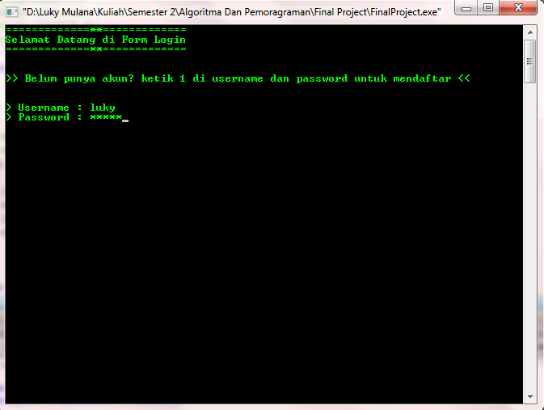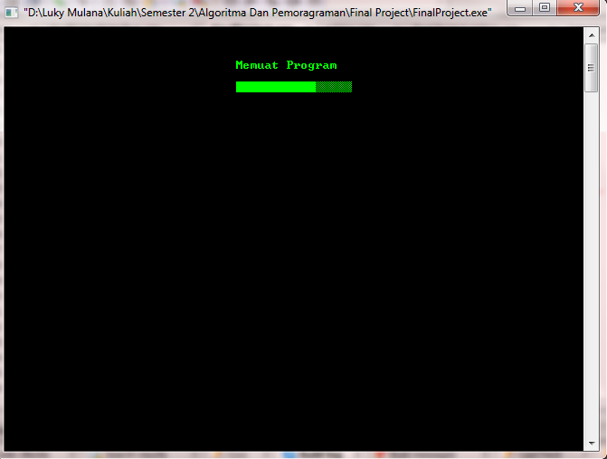LOADING LOGIN

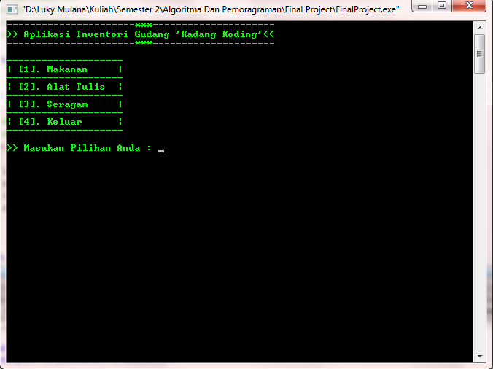

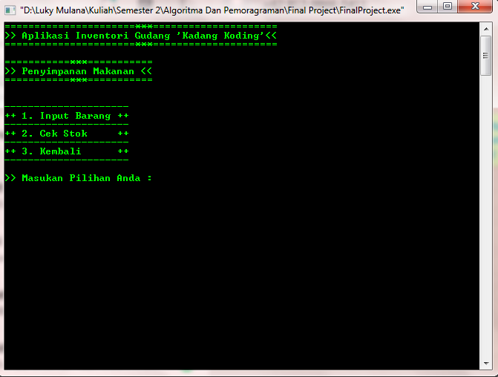MENU UTAMA PENYIMPANAN MAKANAN

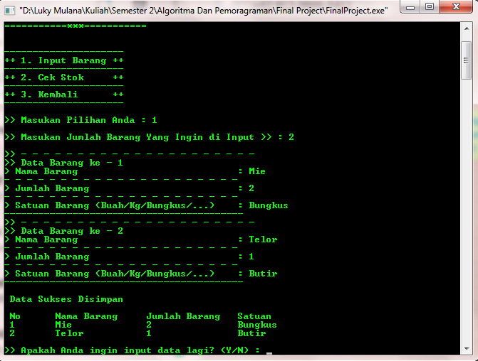INPUT MAKANAN